Generative AI
https://www.youtube.com/watch?v=UrC6jZJdVXk
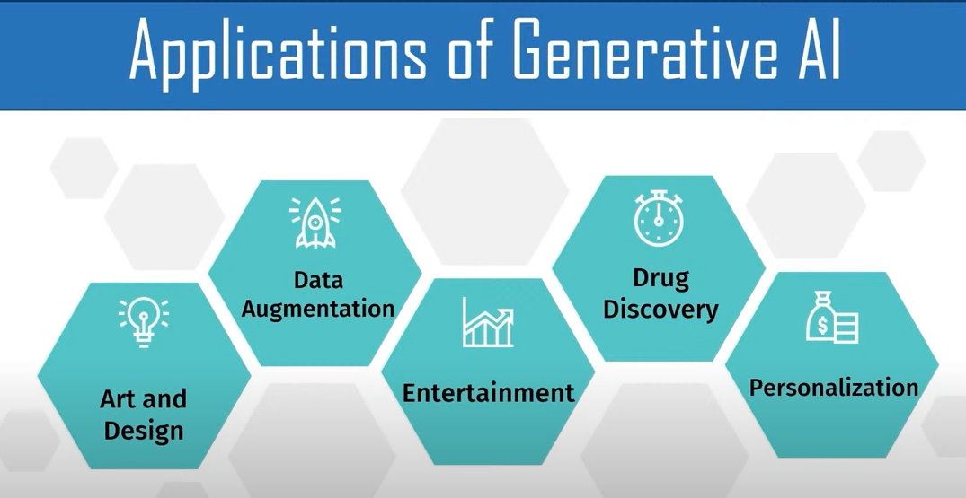

Chat GPT
Bard
Dalle

- Recommendations in streaming systems
- Subset of AI capable to produce text , music , video and other forms
- It is based on deep learning architectures such as Generative Adersarial Network (GANs) or Variational Autoencoders (VAEs)
- It uses machine learning , existing data and user inputs

Google Gemini – previously known as google bard

Images from text – Dezgo

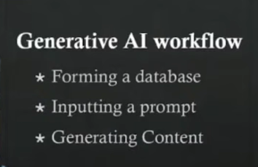

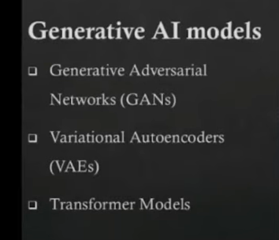

ChatGPT is transformal model

All the 3 are based on neural models .

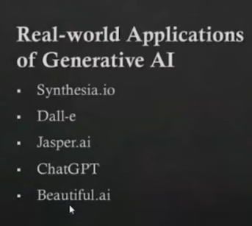

Menti.com for graphs

